**Question 1**

Write the program for deleting an element from the beginning and from any position.

**Input:**

#include<stdio.h>

#include<conio.h>

int main(){

int n,i,j,ch,pos;

int arr[10];

clrscr();

printf(".....Hi Welcome to array deletion......");

printf("\nEnter the size of the array");

scanf("%d",&n);

printf("Enter the elements in array");

for(i=0;i<n;i++){

scanf("%d",&arr[i]);

}

printf("\nYour array is:");

for(i=0;i<n;i++){

printf("\t%d",arr[i]);

}

printf("\n1-To Delete first element\n2-To Delete any position element");

scanf("%d",&ch);

if(ch==1){

for(i=0;i<n;i++){

arr[i]=arr[i+1];

}

n--;

printf("\nFirst ele deleted...");

for(i=0;i<n;i++){

printf("\t%d",arr[i]);

}

}

if(ch==2){

printf("\nEnter Postion of element You want to delete");

scanf("%d",&pos);

for(i=0;i<n;i++){

arr[pos-1]=arr[pos];

pos++;

}

n--;

printf("Array after deletion...");

for(i=0;i<n;i++){

printf("\t%d",arr[i]);

}

}

getch();

return 0;

}

**Output:**

For Deletion Of first element of array.

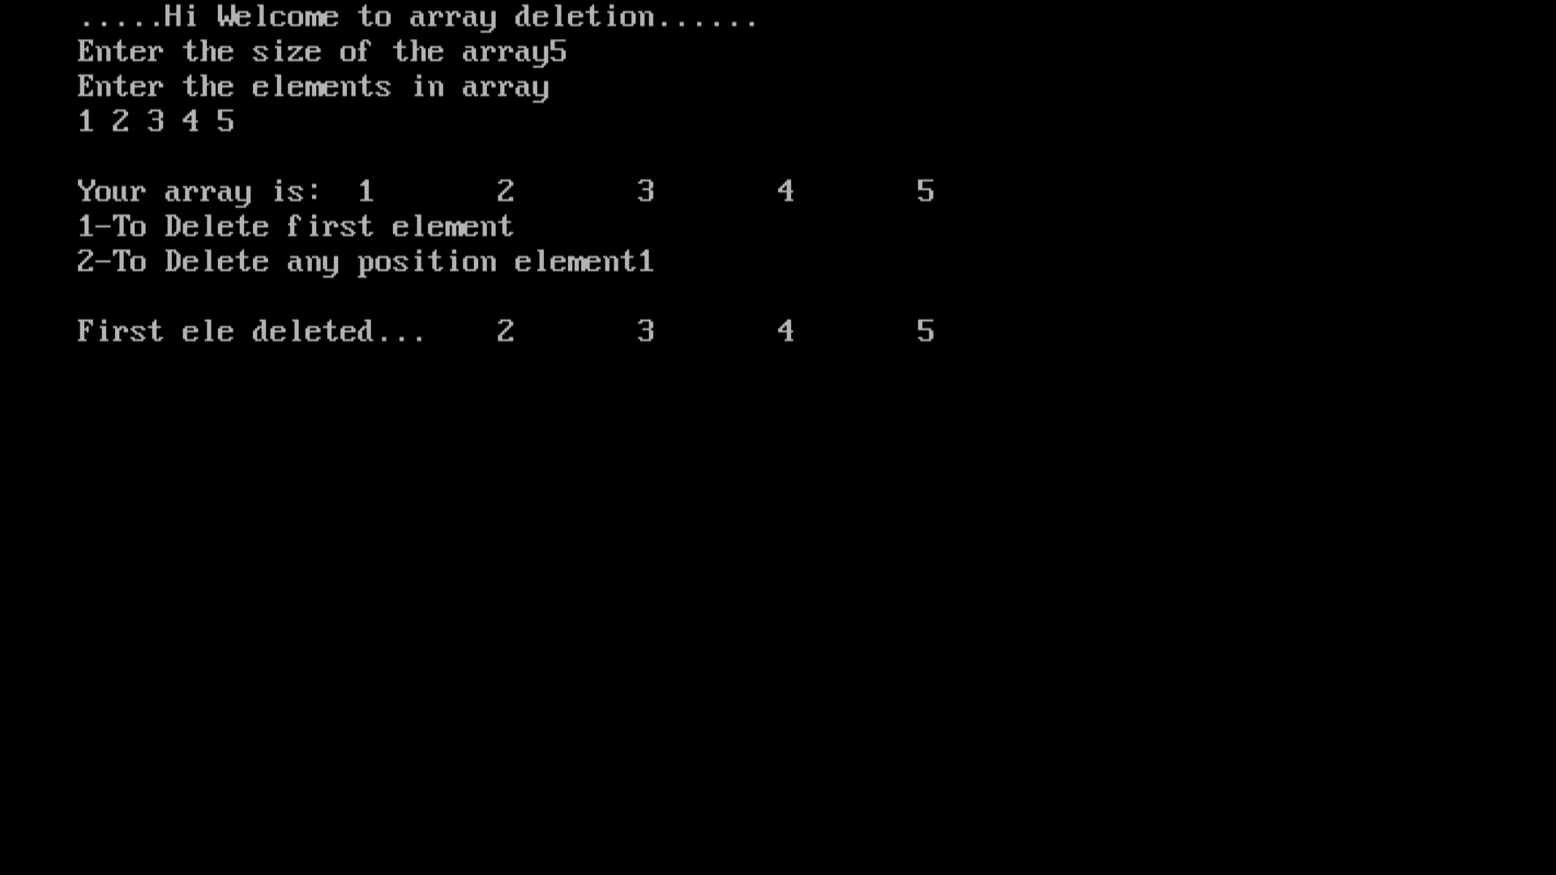

For Deletion of element at particular position(from user).

